**AIDI2004 – AI in Enterprise Systems**

**Lab Assignment 1**

As per the Instructions given in Lecture notes and YouTube links, I had done the following-

1. First step involves displaying the version of Git Software………….

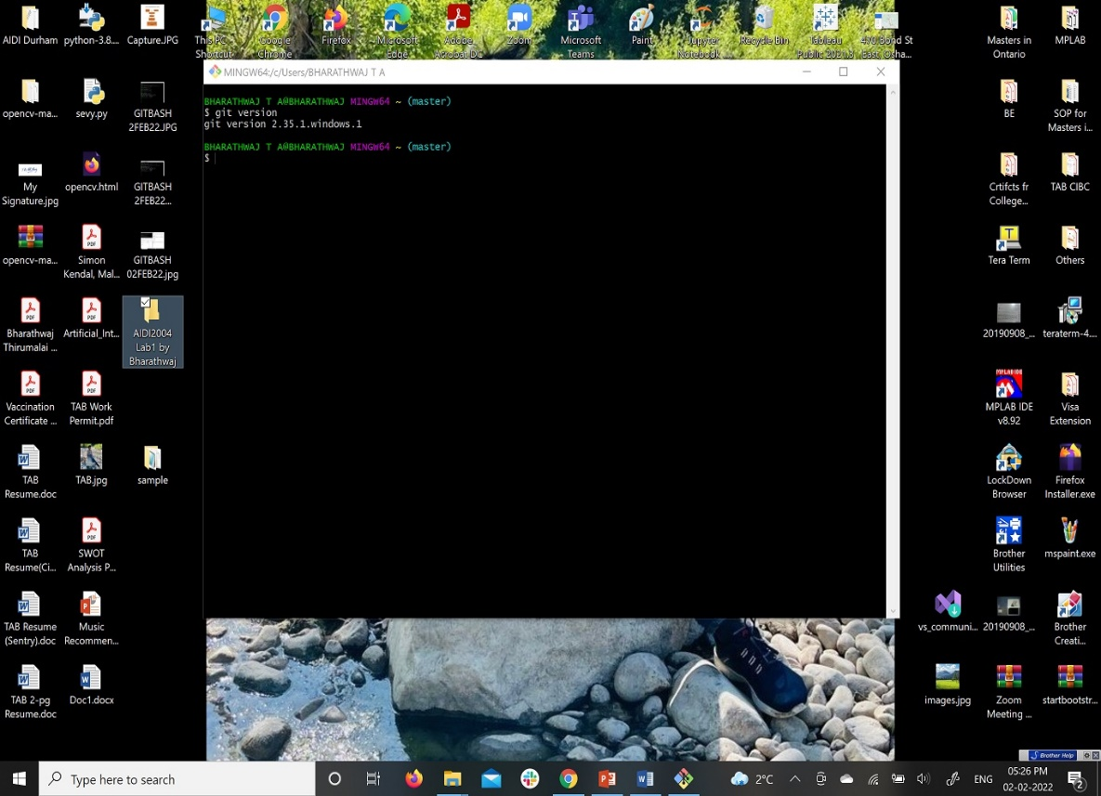

……. and then display of my GitHub and GitLab account.

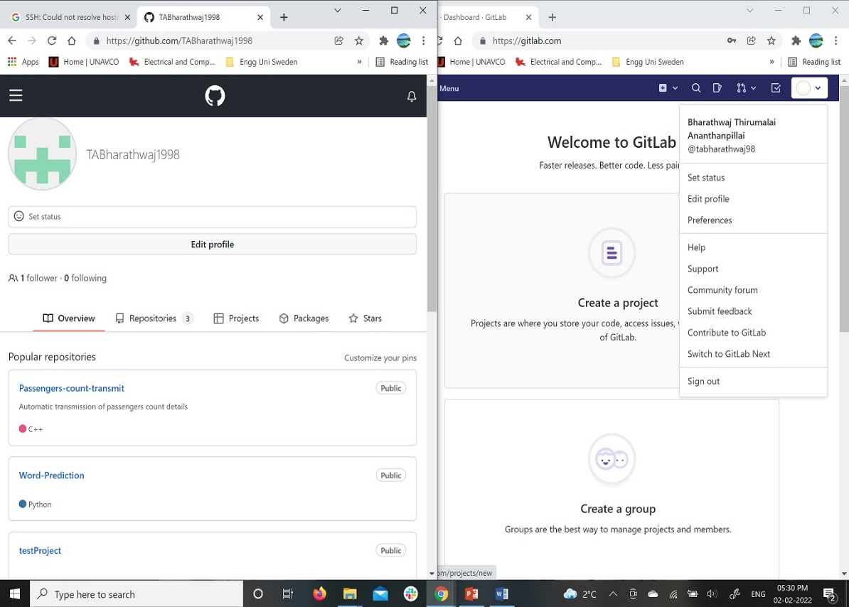

1. Then the next step involves creating a public repository in GitHub, ……..

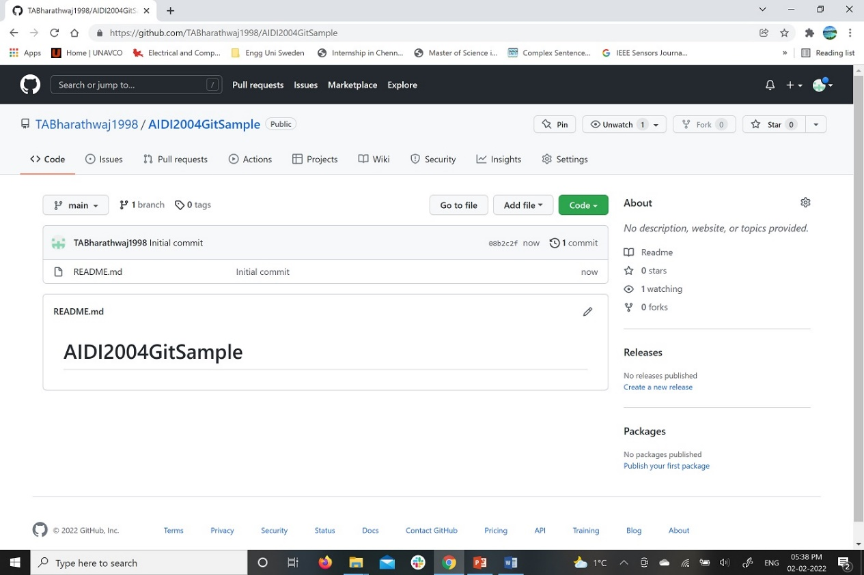

……… initialising .git and utilising pull operation technique to get the README.md file from the Public repository “AIDI2004 Git sample. It results in README.md file stored at “AIDI2004 Lab1 by Bharathwaj” folder which contains the same text comment as shown in Repository.

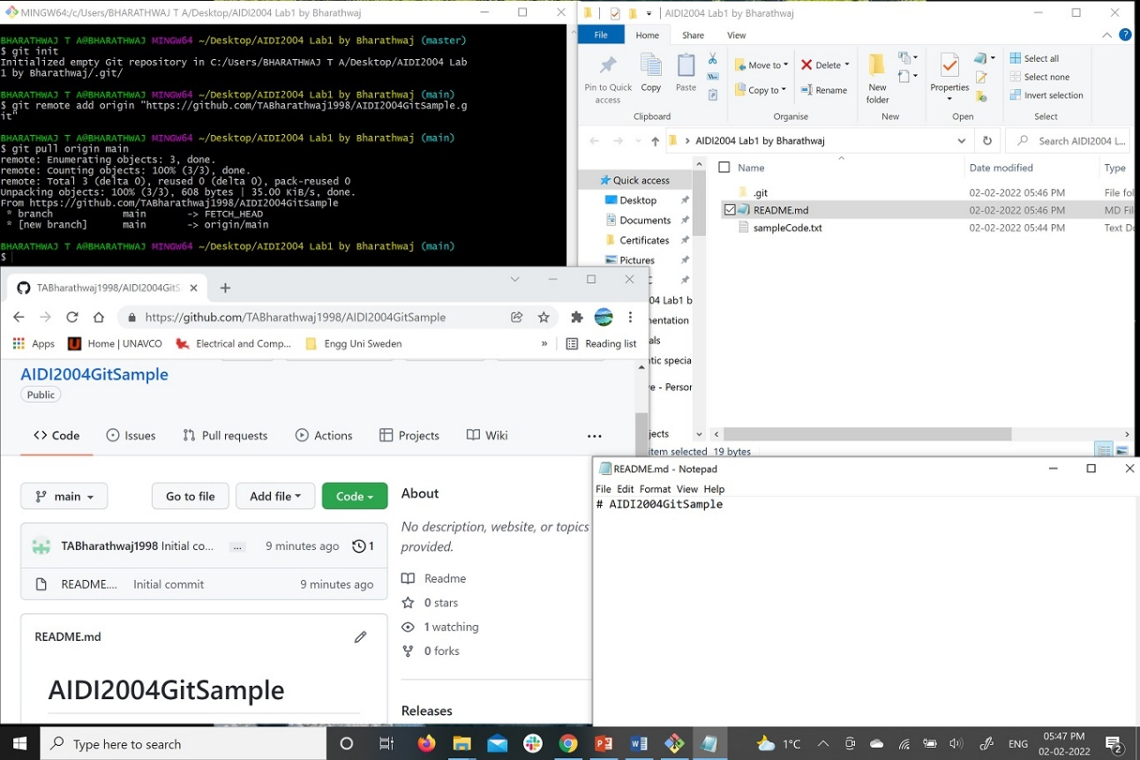

1. Then this diagram focus on successful commit of text file named “sampleCode.txt” in the “AIDI2004 Lab1 by Bharathwaj” folder. The “commit” command is written with statement “Prints Hello World” which will be displayed beside this text file at the repository.

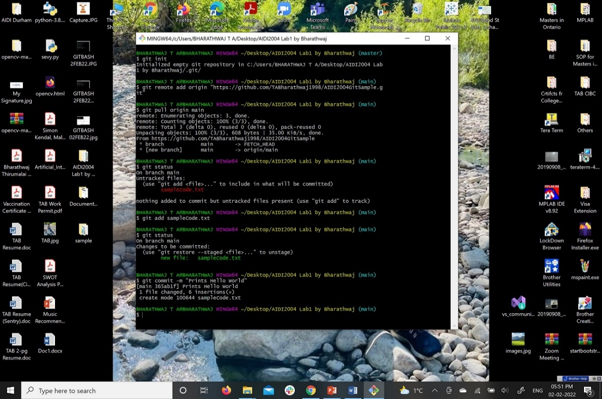

1. Finally the push operation to store the files such as README.md and sampleCode.txt in the repository. 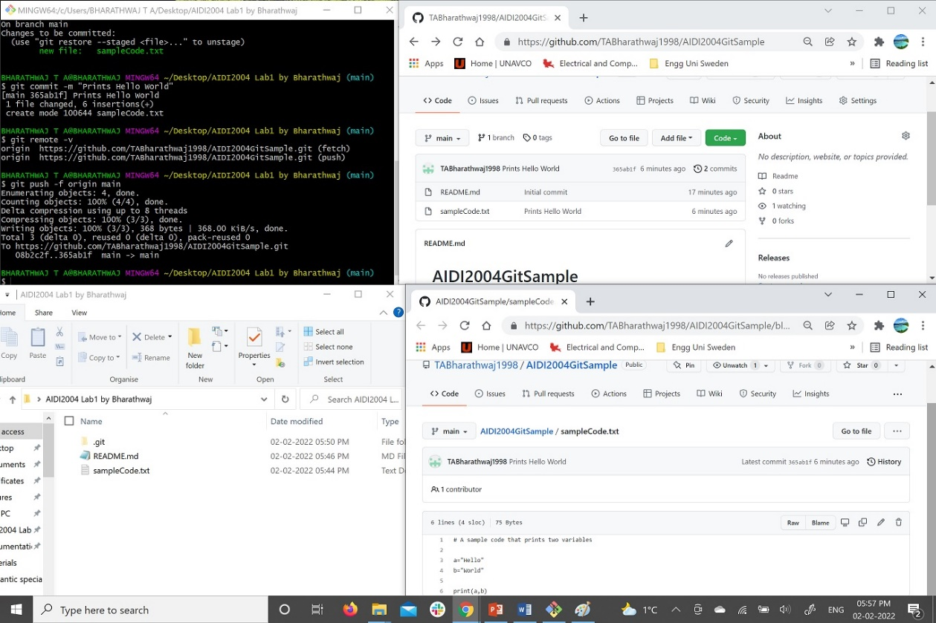

Hence it shows that git is synced with GitHub. The repository link is <https://github.com/TABharathwaj1998/AIDI2004GitSample>